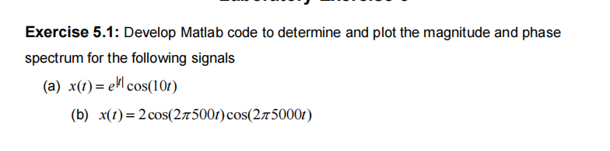
Sol:
clc; clear; close all;

%% Sampling parameters
Fs = 200; % Sampling frequency (Hz) - high enough (> 10 Hz)
T = 1/Fs; % Sampling interval
L = 2048; % Number of samples
t = (-L/2:L/2-1)*T; % Symmetric time axis
f = (-L/2:L/2-1)*(Fs/L);% Frequency axis in Hz

%% -------- Signal (a): x(t) = e^{-|t|} cos(10t) --------
x1 = exp(-abs(t)) .* cos(10*t); % Correct formula with decay

% Fourier Transform using FFT
X1 = fftshift(fft(x1, L));
X1mag = abs(X1)/L;
X1phase = angle(X1);

%% -------- Plot Time-domain --------
figure;
plot(t, x1, 'b', 'LineWidth', 1.5);
xlabel('Time (s)'); ylabel('x_1(t)');
title('Signal x_1(t) = e^{-|t|} cos(10t)');
grid on;

%% -------- Plot Magnitude Spectrum --------
figure;
plot(2*pi*f, X1mag, 'r', 'LineWidth', 1.5); % frequency in rad/s
xlabel('Frequency (rad/s)'); ylabel('|X_1(f)|');
title('Magnitude Spectrum of x_1(t)');
grid on;

%% -------- Plot Phase Spectrum --------
figure;
plot(2*pi*f, unwrap(X1phase), 'k', 'LineWidth', 1.5);
xlabel('Frequency (rad/s)'); ylabel('Phase (rad)');
title('Phase Spectrum of x_1(t)');
grid on;
Figure:
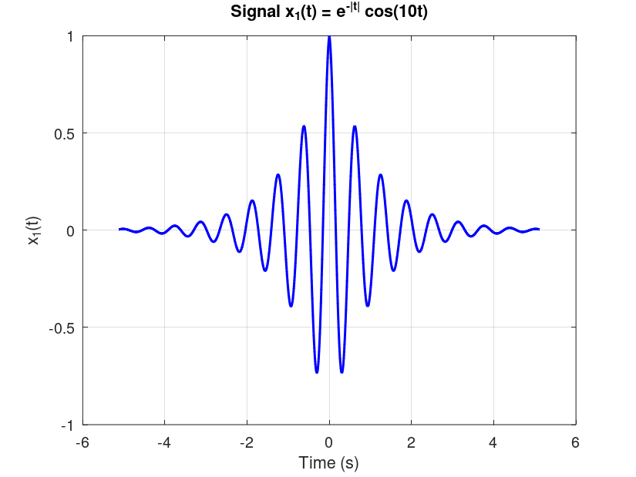
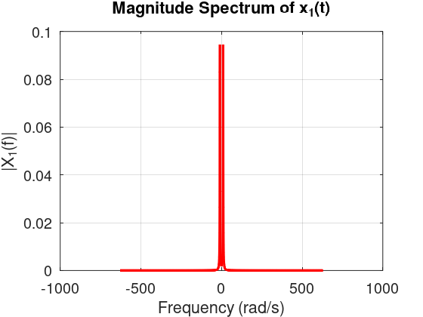BBb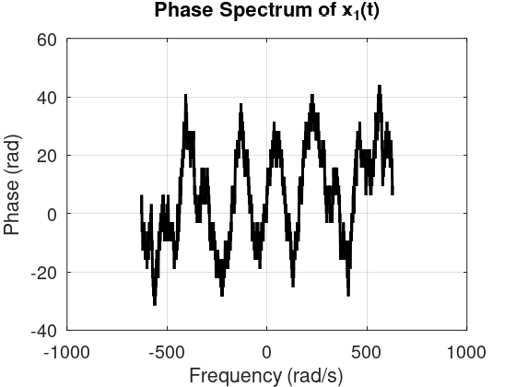
B Sol: clc; clear; close all;

%% Sampling parameters
Fs = 50000; % Sampling frequency (50 kHz, > 2*5500 to satisfy Nyquist)
T = 1/Fs; % Sampling interval
L = 8192; % Number of samples
t = (0:L-1)*T; % Time vector
f = (-L/2:L/2-1)*(Fs/L); % Frequency axis

%% -------- Signal (b): x(t) = 2cos(2π500t)cos(2π5000t) --------
x2 = 2*cos(2*pi*500*t).*cos(2*pi*5000*t);

% Fourier Transform using FFT
X2 = fftshift(fft(x2, L));
X2mag = abs(X2)/L;
X2phase = angle(X2);

%% -------- Plot Time-domain --------
figure;
plot(t(1:1000), x2(1:1000), 'b', 'LineWidth', 1.5); % Show small window for clarity
xlabel('Time (s)'); ylabel('x_2(t)');
title('Signal x_2(t) = 2cos(2π500t)cos(2π5000t)');
grid on;

%% -------- Plot Magnitude Spectrum --------
figure;
plot(f, X2mag, 'r', 'LineWidth', 1.5);
xlabel('Frequency (Hz)'); ylabel('|X_2(f)|');
title('Magnitude Spectrum of x_2(t)');
xlim([-10000 10000]); % focus around frequencies of interest
grid on;

%% -------- Plot Phase Spectrum --------
figure;
plot(f, unwrap(X2phase), 'k', 'LineWidth', 1.5);
xlabel('Frequency (Hz)'); ylabel('Phase (rad)');
title('Phase Spectrum of x_2(t)');
xlim([-10000 10000]);
grid on;
Figure:
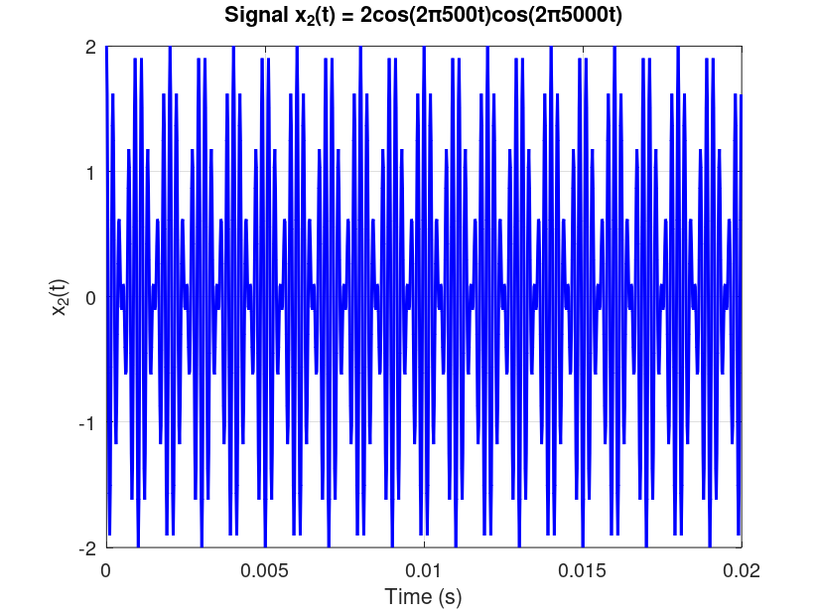
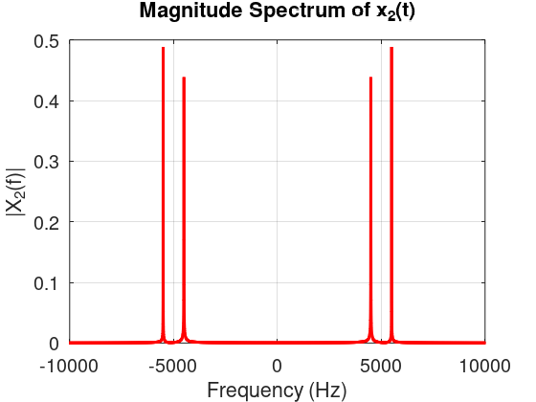
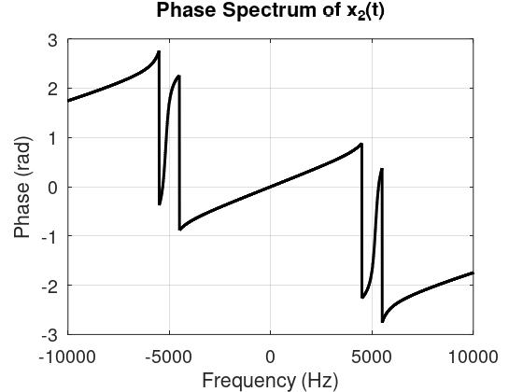
5.2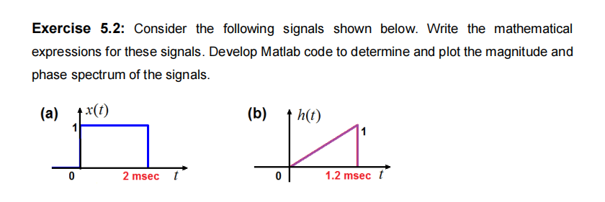
Sol:
clc; clear; close all;

Fs = 100e3; % Sampling frequency (100 kHz)
T = 1/Fs;
L = 2048; % FFT length
t = (0:L-1)*T; % Time vector

%% (a) Rectangular pulse x(t)
x = (t >= 0 & t <= 2e-3); % Rectangular pulse (0 to 2 ms)

% FFT
X = fftshift(fft(x, L));
f = (-L/2:L/2-1)*(Fs/L);

figure;
subplot(3,1,1);
plot(t*1000, x, 'LineWidth',1.5);
xlabel('t (ms)'); ylabel('x(t)');
title('(a) Rectangular Pulse in Time Domain'); grid on; xlim([0 5]);

subplot(3,1,2);
plot(f, abs(X)/max(abs(X)), 'LineWidth',1.5);
xlabel('Frequency (Hz)'); ylabel('|X(f)|');
title('Magnitude Spectrum of x(t)'); grid on; xlim([-5000 5000]);

subplot(3,1,3);
plot(f, angle(X), 'LineWidth',1.2);
xlabel('Frequency (Hz)'); ylabel('∠X(f)');
title('Phase Spectrum of x(t)'); grid on; xlim([-5000 5000]);

%% (b) Triangular pulse h(t)
h = zeros(size(t));
idx = (t >= 0 & t <= 1.2e-3);
h(idx) = t(idx)/(1.2e-3); % Triangular ramp

% FFT
H = fftshift(fft(h, L));

figure;
subplot(3,1,1);
plot(t*1000, h, 'LineWidth',1.5);
xlabel('t (ms)'); ylabel('h(t)');
title('(b) Triangular Pulse in Time Domain'); grid on; xlim([0 5]);

subplot(3,1,2);
plot(f, abs(H)/max(abs(H)), 'LineWidth',1.5);
xlabel('Frequency (Hz)'); ylabel('|H(f)|');
title('Magnitude Spectrum of h(t)'); grid on; xlim([-5000 5000]);

subplot(3,1,3);
plot(f, angle(H), 'LineWidth',1.2);
xlabel('Frequency (Hz)'); ylabel('∠H(f)');
title('Phase Spectrum of h(t)'); grid on; xlim([-5000 5000]);Figure:
